Simulation of UI Design Lifecycle Using RAD Model with Axure RP

Name: AJAY.S Roll.no:240701024

1. Introduction
This project demonstrates the User Interface (UI) design lifecycle using the Axure RP tool, following the Rapid Application Development (RAD) model.
The aim is to design and simulate a food ordering mobile application interface called “ODERLY”, focusing on fast development, user feedback, and iterative improvements.

2. About RAD Model
The Rapid Application Development (RAD) model emphasizes:
- Quick prototyping
- User involvement
- Fast delivery
- Iterative updates
Phases of RAD Model:
- Requirement Planning
- User Design
- Construction
- Cutover (Deployment)

3. UI Design Lifecycle Implementation

3.1 Requirement Planning
In this phase, the main requirements of the food ordering app were identified:
- User login system
- Food browsing (categories like appetizers, desserts, drinks)
- Product details view
- Add to cart functionality
- Order confirmation

3.2 User Design (Wireframing & Prototyping)
Using Axure RP, multiple UI screens were created:
a) Splash Screen
- Displays app name ODERLY
- Food-themed icon (fork, knife, spoon)
- Represents app branding
b) Login Screen
- Fields: Email & Password
- Login button
- Alternative login option
- Signup link
c) Home Screen
- Greeting message: “Hi Goku, are you hungry?”
- Category tabs: All, Appetizer, Dessert, Drinks
- Food list with:
  - Image
  - Name
d) Product Detail Screen
- Food image (e.g., Biriyani)
- Price breakdown:
  - Food cost
  - Service cost
  - Delivery cost
  - Total cost
- “Add to Cart” button
e) Confirmation Screen
- Message: “Product added to cart”
- Options:
  - Continue shopping
  - Continue to cart

3.3 Construction Phase
In this phase:
- Interactive elements were added in Axure RP
- Navigation between screens was implemented
- Buttons (Login, Add to Cart) were linked
- Dynamic behavior simulated (e.g., page transitions)

3.4 Cutover Phase
- Final prototype was tested
- UI usability was evaluated
- Minor improvements were made based on feedback
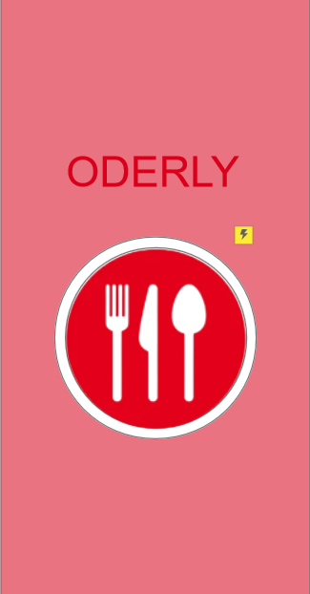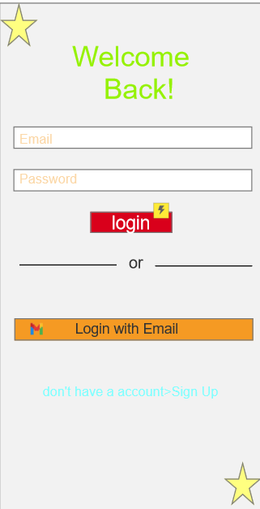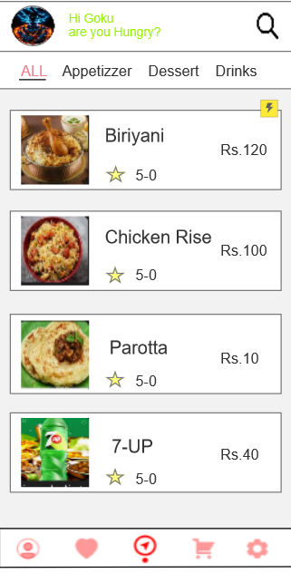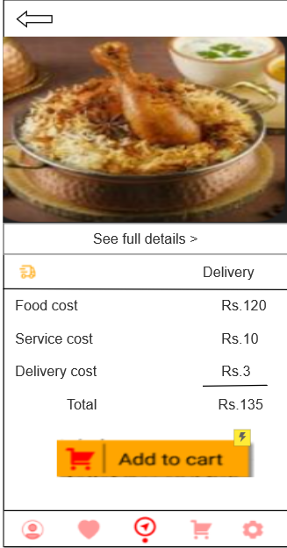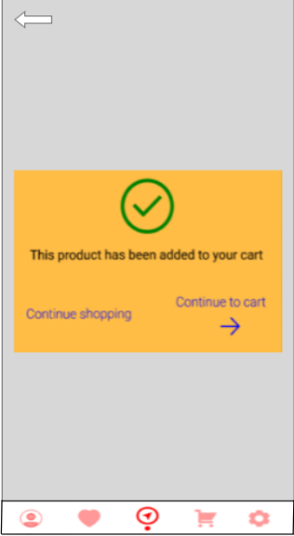

4. Features of the Designed Interface
- Simple and clean layout
- User-friendly navigation
- Categorized food items
- Interactive buttons and transitions
- Real-time simulation of app flow

5. Advantages of Using Axure RP with RAD
- Faster UI development
- Easy prototyping without coding

6. Conclusion
This project successfully demonstrates how the RAD model can be applied to UI design using Axure RP.
By creating multiple interactive screens such as login, home, product details, and confirmation pages, the lifecycle of UI development was effectively simulated. The approach ensures rapid development, continuous feedback, and improved usability, making it suitable for modern application design.
- Improve UI animations
- Connect prototype to real backend

